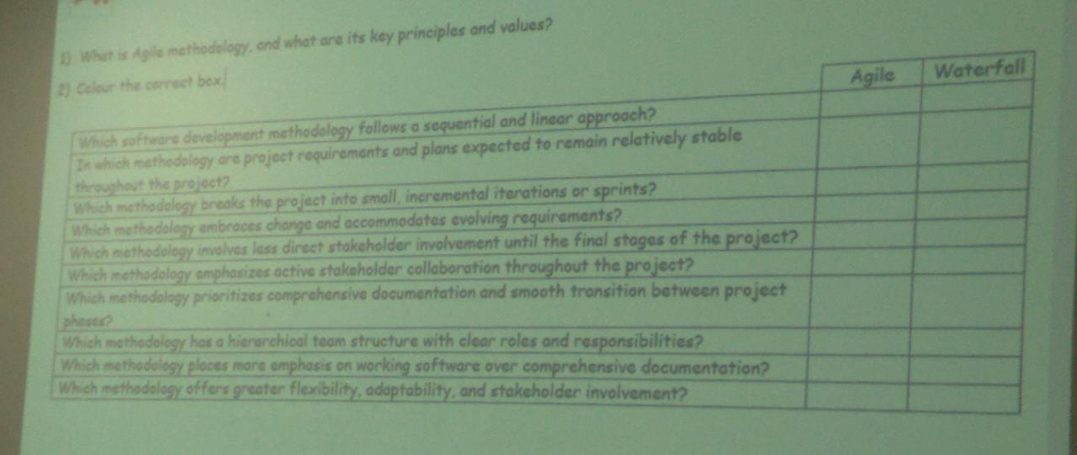

Answer

01.

The term "align methodology" can refer to a few different things. In the context of project management, it refers to the process of aligning the project management approach to the type of project. This includes factors such as the size and complexity of the project, the level of risk involved, and the desired outcome.

The key principles of align methodology include:

* The importance of understanding the context. In order to effectively change gender norms, it is important to understand the specific context in which they operate. This includes factors such as the cultural norms, the legal framework, and the power dynamics.
* The need for dialogue and education. Change is most likely to happen when people are able to have open and honest conversations about gender norms. This can be done through educational programs, workshops, and other forms of dialogue.
* The importance of advocacy. In addition to dialogue and education, it is also important to advocate for change. This can be done through lobbying, public awareness campaigns, and other forms of advocacy.

02. Colour the correct box.

|  |  |  |
| --- | --- | --- |
|  | Agile | Waterfall |
| Witch software development methodology follows a sequential and linear approach? | X |  |
| In which methodology are project requirement and plans expected to remain relatively stable throughout the project | X |  |
| which methodology breaks the project into small, incremental iteration or sprints? |  | X |
| which methodology embraces change and accommodates evolving requirement? |  | X |
| which methodology involves less direct stakeholder involvement unit the final stages of the project? | X |  |
| which methodology emphasizes active stakeholder collaboration throughout the project? |  | X |
| which methodology prioritizes comprehensive documentation and smooth transition between project phases? | X |  |
| which methodology has a hierarchical team structure with clear roles and responsibilities? | X |  |
| which methodology places more emphasis on working software over comprehensive documentation? |  | X |
| which methodology offers greater flexibility, adaptability, and stakeholder involvement? |  | X |